**IMPLEMENTING WEB APPLICATION**

**CREATE IBM DB2 AND CONNECT WITH PYTHON**

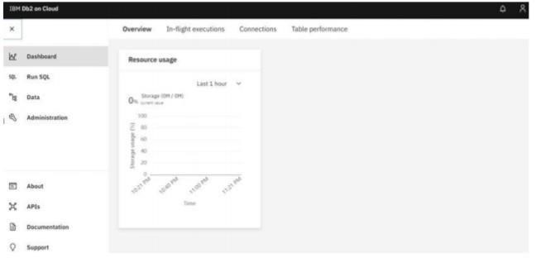

|  |  |
| --- | --- |
| Date | 29 OCT 2022 |
| Team ID | PNT2022TMID11688 |
| Project Name | CONTAINMENT ZONE ALERTING APPLICATION |
| Team Members: | R.Ragavan,K.Sriram,S.Sanjay Krishna,K.Muhammad Afzal |
|  |  |

**IBM DB2**

# DB2 WITH PYTHON

